实验3 ASP.NET常用服务器控件的使用
实验类型：设计性实验 要求：必做 学时：4
实验时间及地点：

实验目的
掌握ASP.NET常用服务器控件的使用。
实验内容
1、设计一个简易四则运算器。
2、设计一个“多选题”页面。
3、设计一个“选课”页面。
4、设计一个装机清单页面。
5、设计一个文件上传页面。
6、在日历中设置节日。
7、设计一个页面综合使用验证控件。
实验步骤
1、设计一个简易四则运算器。
要求加、减、乘、除四个按钮使用同一个Command事件处理过程，设计效果可参考下图。
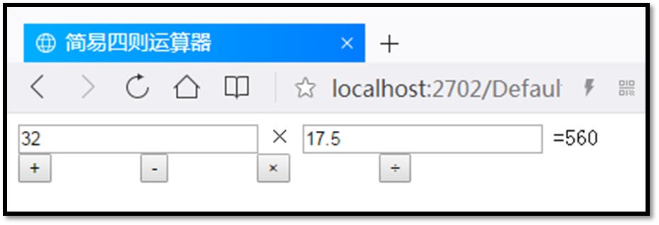
<form id="form1" runat="server">
<div>
<asp:TextBox ID="num1" runat="server"></asp:TextBox>
<asp:Label ID="computLabel" runat="server"></asp:Label>
<asp:TextBox ID="num2" runat="server"></asp:TextBox>
=
<asp:Label ID="resultLabel" runat="server" Text=""></asp:Label>

<div aria-orientation="vertical">
<asp:Button CommandName="plus" runat="server" Text="+" OnCommand="Command" />
<asp:Button CommandName="subtract" runat="server" Text="-" OnCommand="Command" />
<asp:Button CommandName="multiply" runat="server" Text="*" OnCommand="Command" />
<asp:Button CommandName="divide" runat="server" Text="/" OnCommand="Command" />
</div>

</div>
</form>

protected void Command(object sender, CommandEventArgs e)
{
double n1 = double.Parse(num1.Text);
double n2 = double.Parse(num2.Text);
switch (e.CommandName)
{
case "plus":
resultLabel.Text = (n1+n2).ToString();
computLabel.Text = "+";
break;
case "subtract":
resultLabel.Text = (n1 - n2).ToString();
computLabel.Text = "-";
break;
case "multiply":
resultLabel.Text = (n1 * n2).ToString();
computLabel.Text = "*";
break;
case "divide":
resultLabel.Text = (n1 / n2).ToString();
computLabel.Text = "/";
break;
}
}
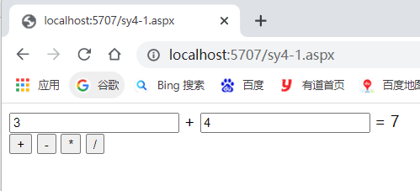
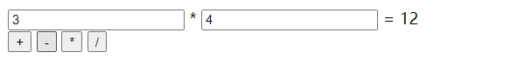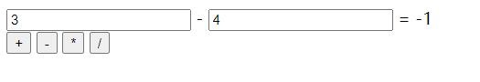
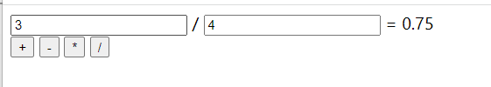

2、设计一个“多选题”页面。
要求使用CheckBoxList控件，设计效果可参考下图。
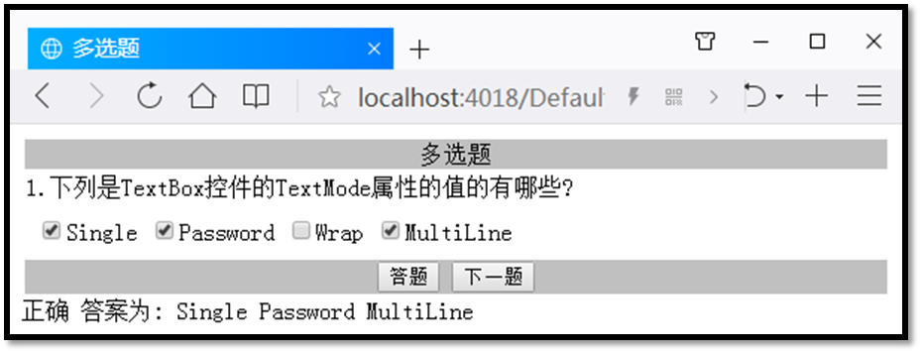
<form id="form1" runat="server">
<div>
<h1>多选题</h1>
<asp:Label ID="Label1" runat="server" Text="1.下列是TextBox控件的TextMode属性的值有哪些？"></asp:Label>

<asp:CheckBoxList ID="CheckBoxList1" runat="server" RepeatDirection="Horizontal">
<asp:ListItem>Single</asp:ListItem>
<asp:ListItem>MultiLine</asp:ListItem>
<asp:ListItem>Password</asp:ListItem>
<asp:ListItem>Wrap</asp:ListItem>
</asp:CheckBoxList>

<asp:Button ID="Button1" runat="server" Text="答题" OnClick="Button1_Click" />
<asp:Button ID="Button2" runat="server" Text="下一题" />
<br />
<asp:Label ID="Label2" runat="server" Text=""></asp:Label>
</div>
</form>

protected void Button1_Click(object sender, EventArgs e)
{
string str = "";
for (int i = 0; i < CheckBoxList1.Items.Count; i++)
{
if (CheckBoxList1.Items[i].Selected)
{
str += " "+ CheckBoxList1.Items[i].Value;
}
}

if (CheckBoxList1.Items[0].Selected &&
CheckBoxList1.Items[1].Selected &&
!CheckBoxList1.Items[2].Selected &&
CheckBoxList1.Items[3].Selected)
{
Label2.Text = "正确" + str;
}
else {
Label2.Text = "错误";
}

}
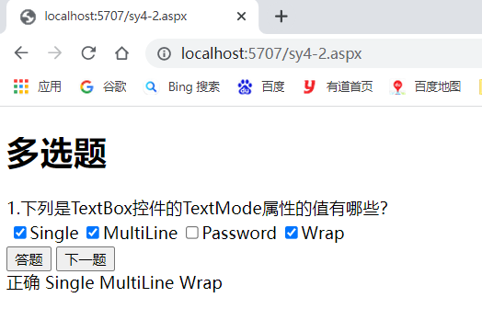
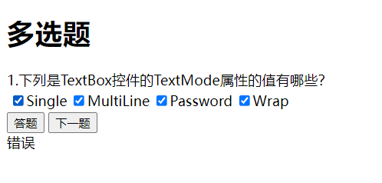
3、设计一个“选课”页面。
要求使用DropDownList控件，设计效果可参考下图。
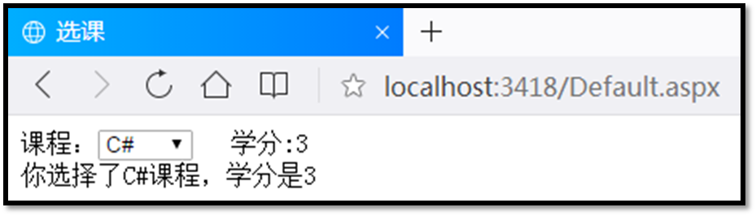
<form id="form1" runat="server">
<div>
<asp:DropDownList ID="DropDownList1" runat="server" OnSelectedIndexChanged="DropDownList1_SelectedIndexChanged" AutoPostBack="True">
<asp:ListItem>VC++</asp:ListItem>
<asp:ListItem>C#</asp:ListItem>
<asp:ListItem>JAVA</asp:ListItem>
</asp:DropDownList>
<br />
<asp:Label ID="Label1" runat="server" Text="Label"></asp:Label>
<br />
<asp:Label ID="Label2" runat="server" Text="Label"></asp:Label>
</div>
</form>

public partial class sy4_3 : System.Web.UI.Page
{
protected void Page_Load(object sender, EventArgs e)
{
int[] grade = { 4, 3, 2 };

Label1.Text = grade[DropDownList1.SelectedIndex].ToString();
}

protected void DropDownList1_SelectedIndexChanged(object sender, EventArgs e)
{
int[] grade = { 4, 3, 2 };

Label1.Text = "学分："+grade[DropDownList1.SelectedIndex].ToString();
Label2.Text = "你选择了 "+DropDownList1.SelectedItem.Text+"课程,学分是"+grade[DropDownList1.SelectedIndex].ToString();
}
}
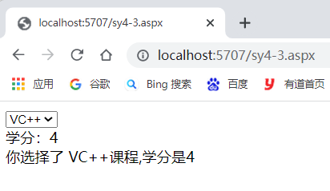
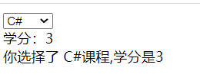
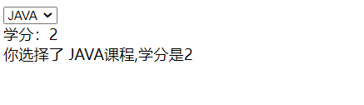
4、设计一个装机清单页面。
要求使用ListBox控件，页面采用DIV+CSS布局，设计效果可参考下图。
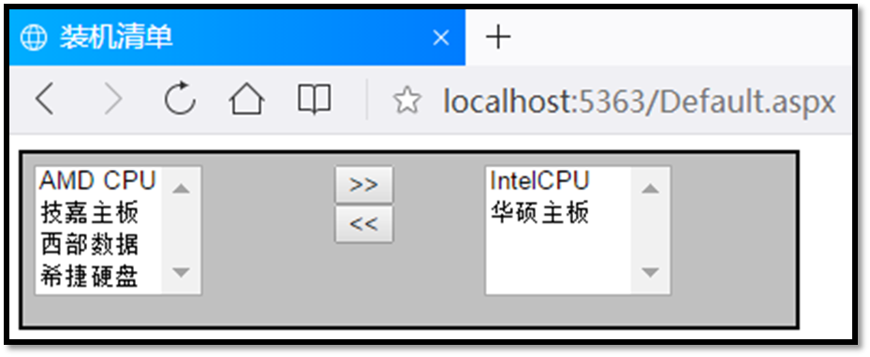
<form id="form1" runat="server">
<div style="width:40%;float:left;text-align:center;">
<asp:ListBox ID="ListBox1" runat="server" OnSelectedIndexChanged="ListBox1_SelectedIndexChanged">
<asp:ListItem>IntelCPU</asp:ListItem>
<asp:ListItem>ADMCPU</asp:ListItem>
<asp:ListItem>华硕主板</asp:ListItem>
<asp:ListItem>技嘉主板</asp:ListItem>
<asp:ListItem>希捷硬盘</asp:ListItem>
<asp:ListItem>西部数据</asp:ListItem>
</asp:ListBox>
</div>

<div style="width:20%;float:left;text-align:center;">
<asp:Button ID="Button1" runat="server" Text=">>" />
<asp:Button ID="Button2" runat="server" Text="<<" />
</div>

<div style="width:40%;float:right;text-align:center;">
<asp:ListBox ID="ListBox2" runat="server" OnSelectedIndexChanged="ListBox2_SelectedIndexChanged"></asp:ListBox>
</div>
</form>

protected void ListBox1_SelectedIndexChanged(object sender, EventArgs e)
{
if (ListBox1.SelectedIndex!=-1)
{
ListBox2.Items.Add(ListBox1.SelectedItem);
ListBox1.Items.Remove(ListBox1.SelectedItem);
ListBox2.ClearSelection();
}
}

protected void ListBox2_SelectedIndexChanged(object sender, EventArgs e)
{
if (ListBox2.SelectedIndex != -1)
{
ListBox1.Items.Add(ListBox2.SelectedItem);
ListBox2.Items.Remove(ListBox2.SelectedItem);
ListBox1.ClearSelection();
}
}
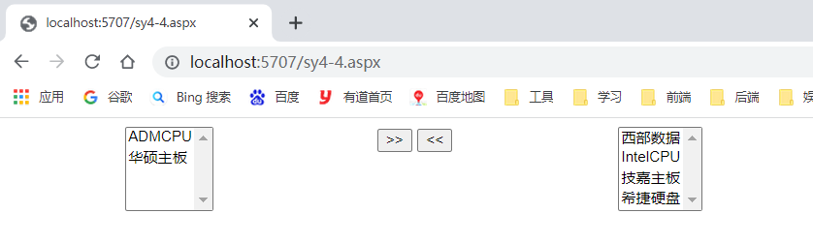
5、设计一个文件上传页面。
要求使用FileUpload控件，设计效果可参考下图。
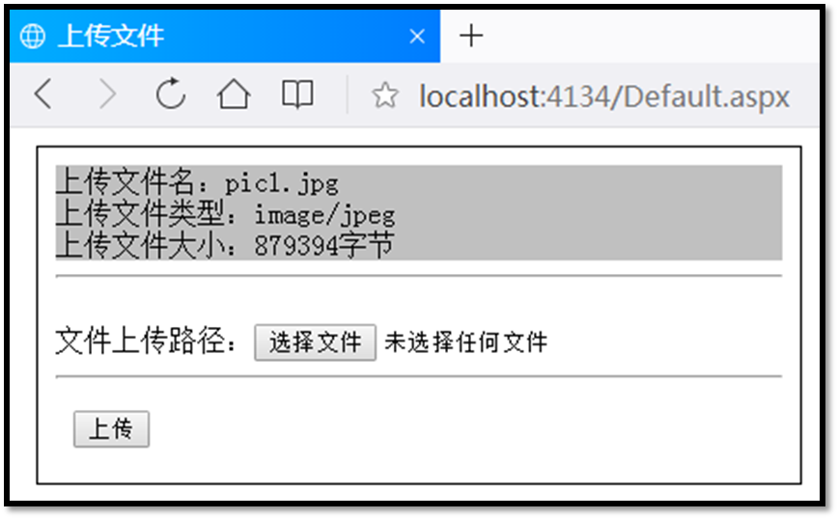
<form id="form1" runat="server">
<div>
<asp:Label ID="Label1" runat="server" Text="Label"></asp:Label>
<hr />
文件上传路径：
<asp:FileUpload ID="FileUpload1" runat="server" />
<br />
<asp:Button ID="Button1" runat="server" Text="上传" OnClick="Button1_Click" style="height: 21px" />
</div>
</form>

protected void Button1_Click(object sender, EventArgs e)
{
string filename, fileExtension, filepath;
if (!FileUpload1.HasFile)
{
Label1.Text = "请先选择要上传简单文件！";
return;
}

filename = FileUpload1.FileName;
fileExtension=System.IO.Path.GetExtension(filename);
if (fileExtension != ".png")
{
Label1.Text = "文件上传类型不正确，请上传.png格式！";
return;
}

filepath = Server.MapPath("~/uploads/");
FileUpload1.PostedFile.SaveAs(filepath+filename);
Label1.Text=
"上传文件名："+filename+"<br/>"+
"上传文件类型:"+FileUpload1.PostedFile.ContentType + "<br/>" +
"上传文件大小：" + FileUpload1.PostedFile.ContentLength.ToString() + "字节";
}
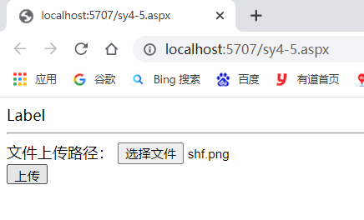
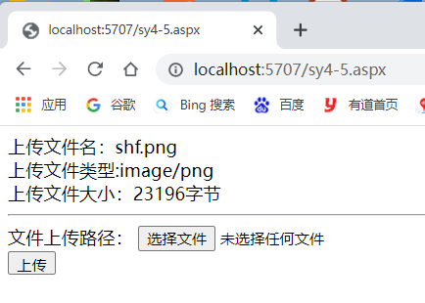

6、在日历中设置节日。
要求使用Calendar控件，设计效果可参考下图。
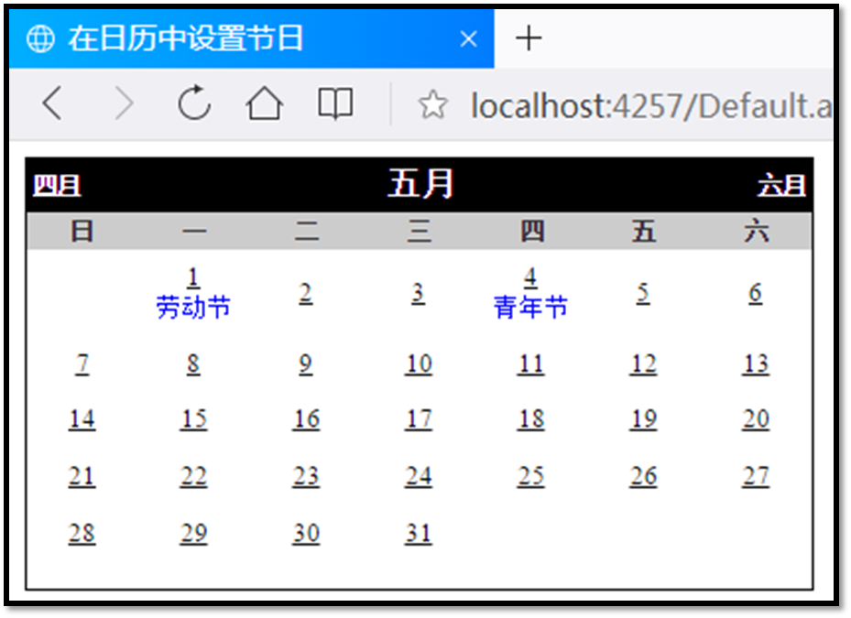
<form id="form1" runat="server">
<div>
<asp:Calendar ID="Calendar1" runat="server" OnDayRender="Calendar1_DayRender" OnSelectionChanged="Calendar1_SelectionChanged"></asp:Calendar>
</div>
</form>

public partial class sy4_5 : System.Web.UI.Page
{
String[][] holidays = new string[13][];
protected void Page_Load(object sender, EventArgs e)
{
for (int i = 0; i < 13; i++)
{
holidays[i] = new string[32];
}
holidays[1][1] = "元旦";
holidays[3][8] = "妇女节";
holidays[5][1] = "劳动节";
holidays[5][4] = "青年节";
holidays[6][1] = "儿童节";
holidays[7][1] = "党的生日";
holidays[8][1] = "建军节";
holidays[10][1] = "国庆节";
}

protected void Calendar1_DayRender(object sender, DayRenderEventArgs e)
{
CalendarDay d = ((DayRenderEventArgs)e).Day;
TableCell c = ((DayRenderEventArgs)e).Cell;
if (e.Day.IsOtherMonth){
e.Cell.Controls.Clear();
}
else
{
String Hol = holidays[e.Day.Date.Month][e.Day.Date.Day];
if (Hol != string.Empty)
{
e.Cell.Controls.Add(new LiteralControl("<br><font color=blue size=2>" + Hol + "</br>")); ;
}
}
}
}
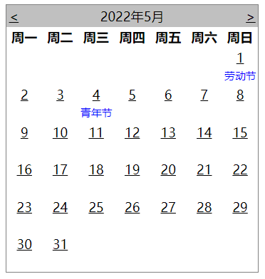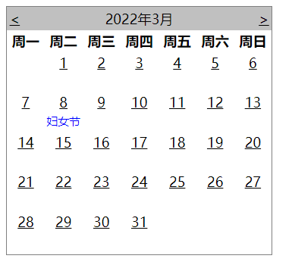
7、设计一个页面综合使用验证控件。
要求使用验证控件，设计效果可参考下图。
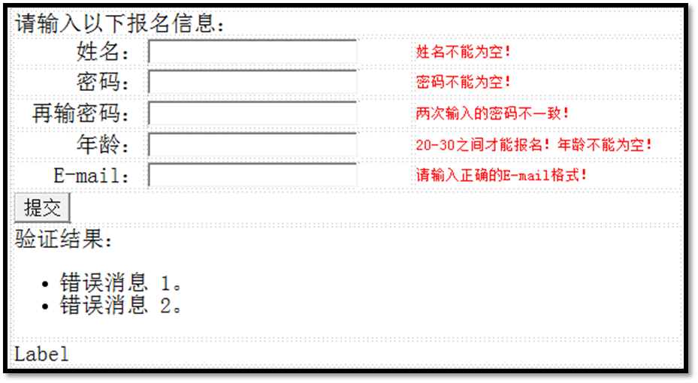

<form id="form1" runat="server">
<div>
姓名：<asp:TextBox ID="TextBox1" runat="server"></asp:TextBox>
<asp:RequiredFieldValidator
ID="RequiredFieldValidator1"
ControlToValidate="TextBox1"
Display="Static"
ForeColor="red"
runat="server"
ErrorMessage="* 姓名不能为空">* 必须输入姓名</asp:RequiredFieldValidator>
<br />

密码：<asp:TextBox ID="TextBox2" runat="server" TextMode="Password"></asp:TextBox>
<asp:RequiredFieldValidator
ID="RequiredFieldValidator2"
ControlToValidate="TextBox2"
Display="Static"
ForeColor="red"
runat="server"
ErrorMessage="* 密码不能为空">* 必须输入密码</asp:RequiredFieldValidator>
<br />

再输入密码：<asp:TextBox ID="TextBox3" runat="server" TextMode="Password"></asp:TextBox>
<asp:RequiredFieldValidator
ControlToValidate="TextBox3"
ID="RequiredFieldValidator3"
ForeColor="red"
runat="server"
Display="Dynamic"
ErrorMessage="* 必须再次输入密码"></asp:RequiredFieldValidator>
<asp:CompareValidator
ControlToCompare="TextBox2"
ControlToValidate="TextBox3"
ForeColor="red"
ID="CompareValidator1"
runat="server"
ErrorMessage="* 两次输入的密码不一致！"></asp:CompareValidator>
<br />

年龄：<asp:TextBox ID="TextBox4" runat="server"></asp:TextBox>
<asp:RequiredFieldValidator
ControlToValidate="TextBox4"
ID="RequiredFieldValidator4"
runat="server"
ForeColor="red"
ErrorMessage="* 必须输入年龄" Display="Dynamic"></asp:RequiredFieldValidator>
<asp:RangeValidator
ID="RangeValidator1"
ControlToValidate="TextBox4"
runat="server"
ForeColor="red"
MaximumValue="30"
MinimumValue="20"
Type="Integer"
ErrorMessage="* 20-30之间才能报名！"></asp:RangeValidator>
<br />

E-mail：<asp:TextBox ID="TextBox5" runat="server"></asp:TextBox>
<asp:RequiredFieldValidator
ControlToValidate="TextBox5"
ForeColor="red"
ID="RequiredFieldValidator5"
runat="server"
ErrorMessage="* 必须输入E-mail" Display="Dynamic"></asp:RequiredFieldValidator>
<asp:RegularExpressionValidator
ControlToValidate="TextBox5"
ForeColor="red"
ValidationExpression="^[a-zA-Z0-9_-]+@[a-zA-Z0-9_-]+(\.[a-zA-Z0-9_-]+)+$"
ID="RegularExpressionValidator1"
runat="server"
ErrorMessage="* 请输入正确的E-mail格式"></asp:RegularExpressionValidator>
<br />
</div>
<asp:Button ID="Button1" runat="server" Text="提交" OnClick="Button1_Click" />
<hr />
<asp:ValidationSummary ID="ValidationSummary1" runat="server" />
<hr />
<asp:Label ID="Label1" runat="server" Text="Label"></asp:Label>
</form>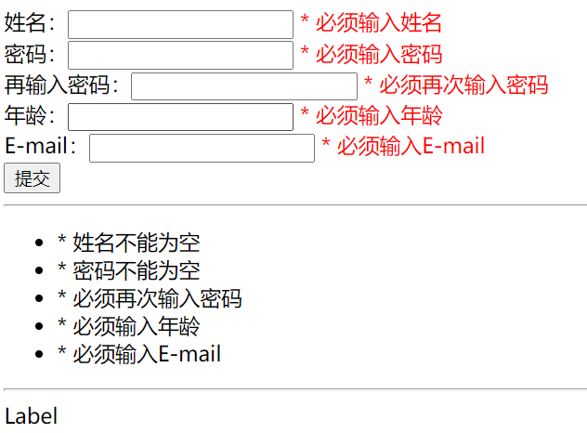
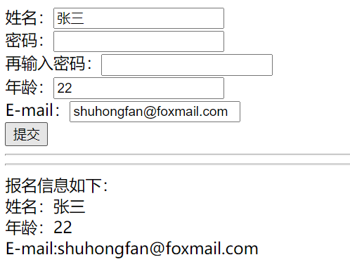

实验小结
通过本次实验我学会使用ASP中的几个常用控件，包括button中的Command事件、CheckBoxList控件、DropDownList控件、ListBox控件、FileUpload控件、Calendar控件、验证控件的使用。

